Hadoop Basic Commands

1. mkdir

Hadoop HDFS mkdir Command Usage

mkdir

Hadoop HDFS mkdir Command Example

hdfs dfs -mkdir /abc

Hadoop HDFS mkdir Command Description

This HDFS command takes path URI’s as an argument and creates directories.

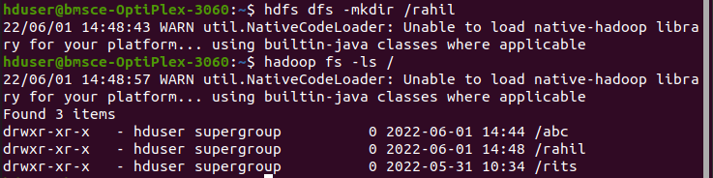

2. ls

Hadoop HDFS ls Command Usage

ls

Hadoop HDFS ls Command Example

hadoop fs -ls /

Hadoop HDFS ls Commnad Description

This Hadoop HDFS ls command displays a list of the contents of a directory specified by path provided by the user, showing the names, permissions, owner, size and modification date for each entry.



3. put

Hadoop HDFS put Command Usage

put

Hadoop HDFS put Command Example

hdfs dfs -put /home/hduser/Desktop/Welcome.txt /abc/WC.txt

Hadoop

HDFS put Command Description

This hadoop basic command copies the file or directory from the local file system to the destination within the DFS.

Display the contents of the file WC.txt

hdfs dfs -cat /abc/WC.txt



4. copyFromLocal

Hadoop HDFS copyFromLocal Command Usage

copyFromLocal

Hadoop HDFS copyFromLocal Command Example

hdfs dfs -put /home/hduser/Desktop/Welcome.txt /abc/WC.txt

Hadoop HDFS copyFromLocal Command Description

This hadoop shell command is similar to put command, but the source is restricted to a local file reference.

Display the contents of the file WC2.txt

hdfs dfs -cat /abc/WC2.txt



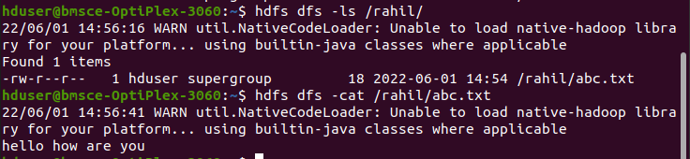

5. get

Hadoop HDFS get Command Usage

get [-crc]

i.Hadoop HDFS get Command Example

hdfs dfs -get /abc/WC.txt /home/hduser/Downloads/WWC.txt

This HDFS fs command copies the file or directory in HDFS identified by the source to the local file system path identified by local destination.

ii.Hadoop HDFS get Command Example

hdfs dfs -getmerge /abc/WC.txt /abc/WC2.txt /home/hduser/Desktop/Merge.txt

This HDFS basic command retrieves all files that match to the source path entered by the user in HDFS, and creates a copy of them to one single, merged file in the local file system identified by local destination.

iii. Hadoop HDFS get Command Example

hadoop fs -getfacl /abc/

This Apache Hadoop command shows the Access Control Lists (ACLs) of files and directories.



6. copyToLocal

Hadoop HDFS copyToLocal Command Usage

copyToLocal

Hadoop HDFS copyToLocal Command Example

hdfs dfs -copyToLocal /abc/WC.txt /home/hduser/Desktop

Similar to get command, only the difference is that in this the destination is restricted to a local file reference.

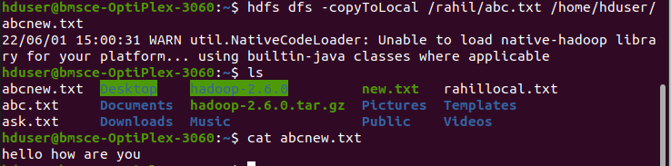

7. cat

Hadoop HDFS cat Command Usage

cat

Hadoop HDFS cat Command Example

hdfs dfs -cat /abc/WC.txt

This Hadoop fs shell command displays the contents of the filename on console or stdout.

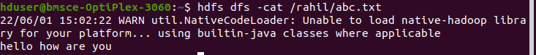

8. mv

Hadoop HDFS mv Command Usage

mv

Hadoop HDFS mv Command Example

hadoop fs -mv /abc /FFF

hadoop fs -ls /FFF

This basic HDFS command moves the file or directory indicated by the source to destination, within HDFS.

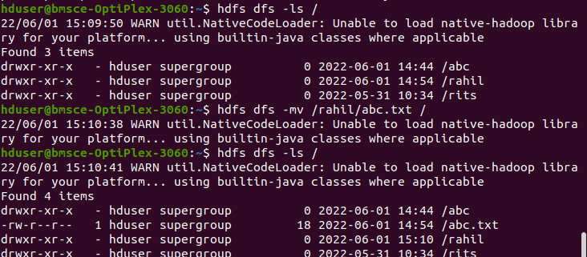

9. cp

Hadoop HDFS cp Command Usage

cp

Hadoop HDFS cp Command Example

hadoop fs -cp /CSE/ /LLL

hadoop fs -ls /LLL

The cp command copies a file from one directory to another directory within the HDFS.

